23 September 2016

Website Specification

**Project :**

Creating Jivin’ Jazz website, sharing whole range Jazz recordings collected by Miles Coltrane.

**[Client]**

|  |  |
| --- | --- |
| **Name** | Miles Coltrane |
| **Company** | Jivin’ Jazz |
| **Address** | 130 Madras St  Christchurch Central  Christchurch |
| **Email** | miles@jivin-jazz.co.nz |
| **Phone** | 03 940 8000 |

**[Developer]**

|  |  |
| --- | --- |
| **Name** | Satoshi Sugimura |
| **Company** | SatoSystem |
| **Address** | 278 Tuam St  Christchurch Central  Christchurch |
| **Email** | satoshi@satosystem.co.nz |
| **Phone** | 022-390-7200 |

For Jivin’ Jazz website

# Introduction

## About this document

This document is a website specification for Jivin’ Jazz website. The purpose of the document is to define the website’s goals, target audience, website design, hosting, timeline and budget of the project.

## About the project

This is a website building project for Mr. Miles Coltrane, who is a collector of live jazz recordings and the owner of a company named Jivin’ Jazz. He wishes to share his vast collection with the world via the World Wide Web. Especially interested in introducing younger people to a range of jazz and getting them enthused about it. The website will be an informative website to share his recording collection to the public.

Table of content

Introduction i

About this document i

About the project i

Client details 1

About the client 1

About the company 1

Goals 1

Objectives 1

Target audience 2

Personas 2

Website structure 5

Required pages 5

Sitemap 5

Website content 6

User interaction 6

Do’s 6

Don’ts 6

Design 7

Large screen sample: width 100em 7

Small screen sample: width 30em 9

Accessibility 9

Search engine optimization 10

Link popularity 10

Page titles 11

URLs 11

Domain name 12

Status 12

Registration price 12

Hosting 13

Requirements 13

Options 13

HostPapa Business 14

crazydomains Premium 15

Copyright 16

Copyright notice 16

About copyright 16

Privacy 17

Collection of information 17

How we will use your information 17

Unsubscribing 17

Usability testing 17

Timeline 18

Budget 19

Support and maintenance 19

# Client details

## About the client

The client is Miles Coltrane, who is a collector of live jazz recordings. He wishes to share his vast collection with the world via the World Wide Web. He is collecting recordings for 40 years and has 10,000 recordings. He is familiar with whole range of jazz music. He finds the products and records himself and not buying. His favorite instrument is fretless base, which he plays himself. He is not interested in owning events like open mic nights.

## About the company

“Jivin’ Jazz” is his company established in 1999. It is a small company and he is the sole staff. The company manages the rights for his recordings. The company does not sell any goods. There is no competition.

**Contact details**

|  |  |
| --- | --- |
| Address | 130 Madras St, Christchurch Central, Christchurch |
| Email | [miles@jivin-jazz.co.nz](mailto:miles@jivin-jazz.co.nz) |
| Phone number | 03 940 8000 |

# Goals

To have a successful website that broadens people's appreciation of jazz. Especially interested in introducing younger people to a range of jazz and getting them enthused about it.

# Objectives

The project sets following as objectives.

**Achieve 1,000 page views per day at the end of first 3 months.**

To measure successfulness of the website, we set the number of page views as an objective. Unfortunately, there is no good answer for how many page views should a website get. So we set 1,000 page views on a tentative basis and will review the objective at the end of first 3 months.

**Achieve 35% ratio of young people (aged 15-25) on newsletter signup.**

To measure if the website is appealing to young people, we will put a survey on the newsletter signup form. If 35% of subscription are by young people, we can say that the website is successfully appealing to younger generation.

# Target audience

The main target is young people aged 15-25.

The website should appeal to a wide age range.

The website should appeal to who does not usually listen to jazz music.

# Personas

Personas represent the users. As the main target of this website is young people, we create two different personas within this range of age.



Glenn Walsh

|  |  |
| --- | --- |
| Age | 16 |
| Role | A student who loves music but haven’t been interested in jazz |
| Computer Literacy | Medium. Usually use mobile and not familiar with desktop. |
| Music Favor | Rock. Playing drums in a school band. |

**Goal**

* Find new kind of music that he can be crazy about.

**Frustrations**

* Doesn’t look 16 years-old.
* Playing rock drums for 2 years, gradually getting bored, looking for something new.

**Narrative**

Glenn is 16 years old, single, and a student at Burnside high school. His mother loves music and thus he grew up listening to many kinds of music. His mother’s favorite musicians are: The Eagles, Cream, Eric Clapton, The Police, Sting, The Allman Brothers Band, Lynyrd Skynyrd and Brecker Brothers. He first liked Hotel California of The Eagles because he could imagine the scenery and he could felt smells of dust. As he grew he gradually became to like rock music. The first album he bought was Californication of Red Hot Chili Peppers. He started playing drums when he was 14, when he and his friends decided to begin a rock band. He chose to play drums because he wasn’t a good singer and other instruments like guitar or bass looked difficult. Playing rock drums for 2 years, he started to get bored of its monotonous rhythm and looking for something new.



Hanna Tanaka

|  |  |
| --- | --- |
| Age | 24 |
| Role | A business woman who casually listens to music |
| Computer Literacy | High. She uses computer for her daily work and good at searching. |
| Music Favor | Doesn’t have specific favor. Usually listen to hit music coming from car radio. |

**Goal**

* Find information about Pat Metheny.

**Frustrations**

* She finds some good music from time to time, but not much information about the player is provided.

**Narrative**

Hanna is 24 years old, single, and working as a statistics analyst at Statistics New Zealand. She loves people and often goes out with her friends. Recently when she was at a bar with one of her friends, a nice music came to her ear and the friend taught her that it’s Pat Metheny. She got interested and wants to find out more about the musician.

# Website structure

This section provides the list of pages and a sitemap.

## Required pages

* Home
* Musician Information
* Recording Index
* Recordings (three pages)
* Blog
* About Us
* Contact Us

## Sitemap

Home

About Us

Contact Us

Recording Index

Musician Information

Recording

Blog

Recording

Recording

Every pages have navigation links to Home and pages in the first row.

# Website content

This section gives an overview of the contents on the website.

|  |  |
| --- | --- |
| Pages | Contents |
| Home | Warm welcome to Jivin’ Jazz. Navigation to other pages.  Links to social media (Facebook, Instagram, Twitter).  Search box to search musician information and recording by name of musician or song. |
| Musician Information | Introduction of a musician.  Biography, discography, primary instruments, photos. |
| Recording Index | List of the recordings for the musician.  List will be made of tile styled links with images and descriptions. |
| Recording | A recording of the musician with video/audio/photo.  Explanation text about the recording. No auto play. |
| Blog | 3 articles about recent recordings, performances or random thoughts about jazz. |
| About Us | Introduction of Jivin’ Jazz and Miles Coltrane.  Newsletter signup form.  Links to social media (Facebook, Instagram, Twitter). |
| Contact Us | Contact information of Jivin’ Jazz and Miles Coltrane.  Physical address, email address and phone number.  Contact form. |

# User interaction

This section describes what users will be able to do, how to implement them and what is not necessary at the website.

## Do’s

|  |  |
| --- | --- |
| What users will be able to do? | Implementation |
| Find out information about musicians | Create Musician Information page. |
| Watch live videos | Put videos on Recordings page. |
| Play audio | Put audios on Recordings page. |
| Sign up to newsletter | Create Newsletter signup form in About Us page. |
| Read blog | Create Blog page. |
| Comment on the blog posts | Implement comment function on blog page. |

## Don’ts

* Log in

# Design

Following are sample images of Musician Information page. Header (logo and menu) is always on top of the screen. Copyright and SNS links are located on footer.

## Large screen sample: width 100em

Width of the contents is 80em.

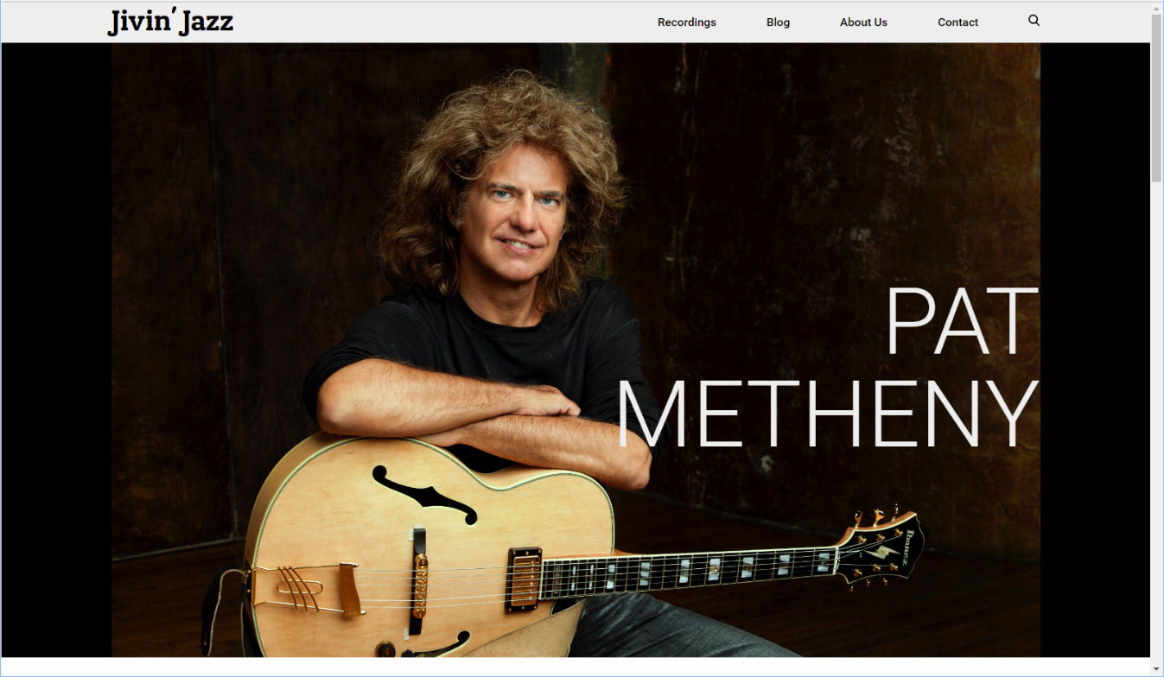

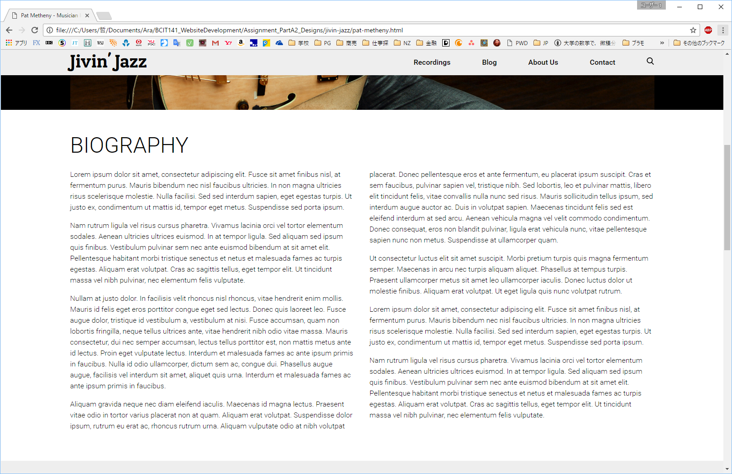

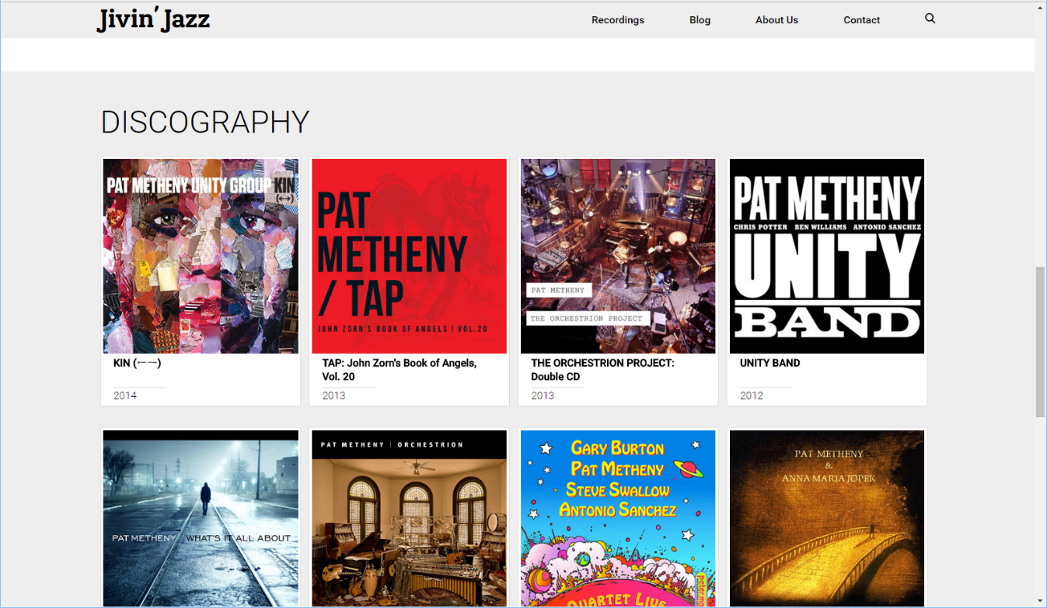

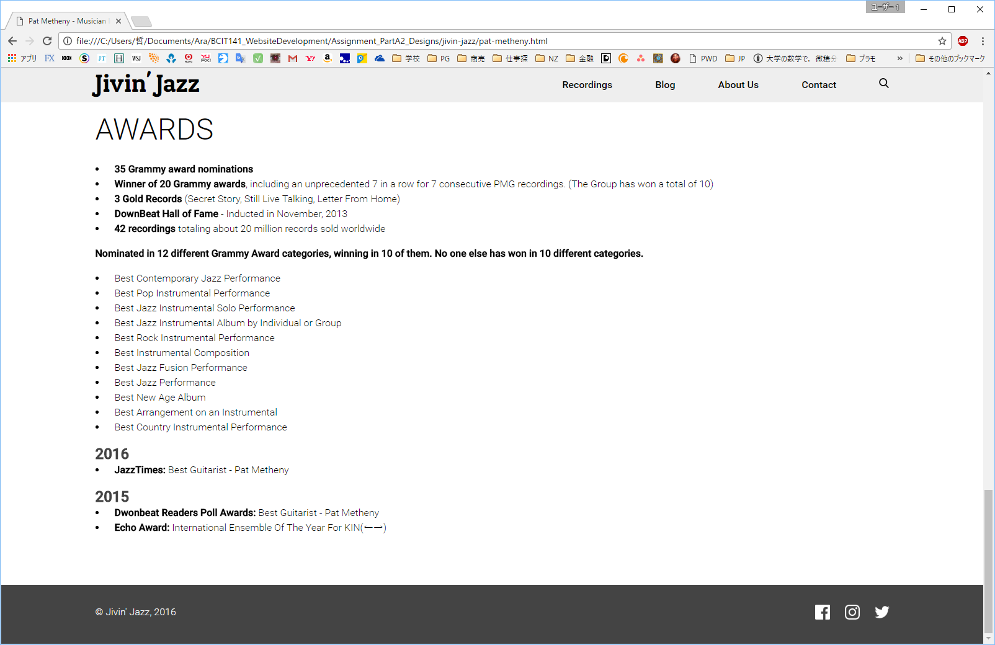

## Small screen sample: width 30em

Width of the contents is 100% with a little margin on both sides. Menu on header changes to hamburger icon and it extends when clicked.

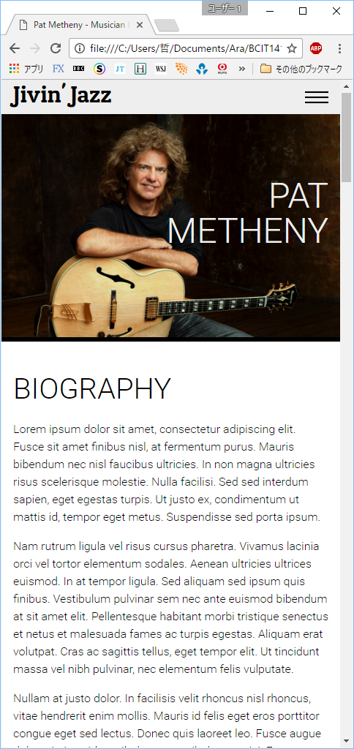 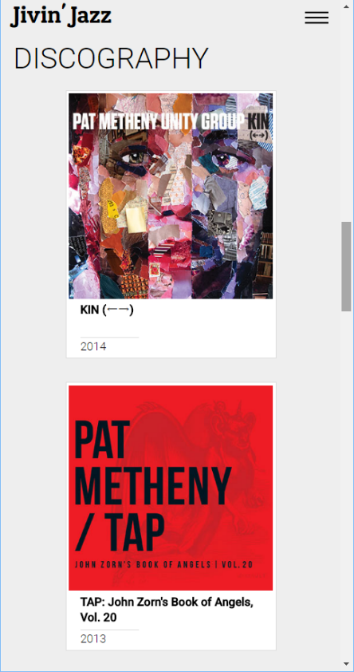 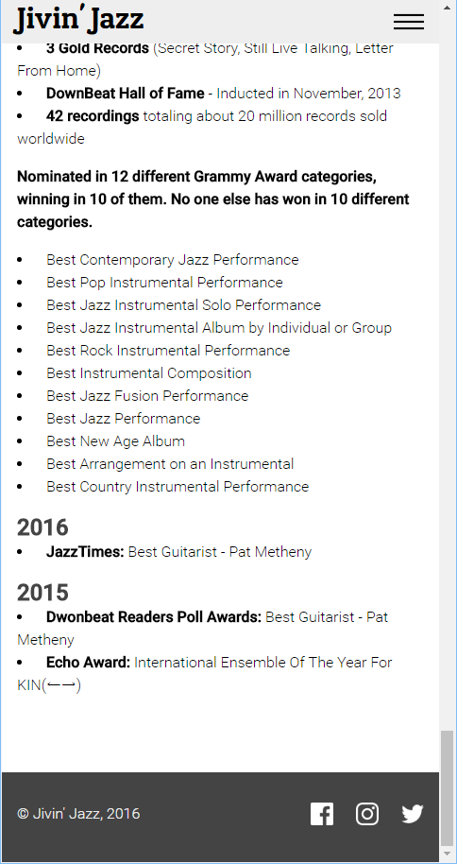

# Accessibility

We build the website that meets Web Content Accessibility Guidelines (WCAG) 2.0 requirements.

<https://www.w3.org/TR/WCAG20/>

|  |  |
| --- | --- |
| Guideline | Implementation |
| Guideline 1.1 – Text Alternatives | Provide text alternatives for all audio and video contents.  If use CAPTCHA on newsletter signup form, provide alternative forms. |
| Guideline 1.2 – Time-based Media | For both Audio-only and Video-only media, provide alternative text to inform about the media. |
| Guideline 1.3 – Adaptable | Create semantically correct HTML. |
| Guideline 1.4 – Distinguishable | Use distinguishable colour scheme (enough contrast).  Don’t play medias automatically and provide audio control. |
| Guideline 2.1 – Keyboard Accessible | Leave this to browsers. |
| Guideline 2.2 – Enough Time | The web pages do not contain contents with timing. |
| Guideline 2.3 – Seizures | The web pages do not contain anything that flashes more than three times in any one second period. |
| Guideline 2.4 – Navigable | All the web pages provide navigation links in header of footer. |
| Guideline 3.1 – Readable | Use English only on the web pages. Do not use abbreviations without explanation. |
| Guideline 3.2 – Predictable | The web pages do not initiate a change when receiving focus or input.  Changes are initiated only by user request. |
| Guideline 3.3 – Input Assistance | In the newsletter signup form, automatically detect an input error (when input is not an email address).  Provide labels for the contents require user input. |
| Guideline 4.1 – Compatible | Create semantically correct HTML. Validate the html files. |

# Search engine optimization

This section describes what techniques will be used to optimize the web pages.

We will use following techniques.

* Improve link popularity
* Create unique, accurate page titles
* Improve the structure of URLs

## Link popularity

One of the major approaches search engines calculate page rank is by link popularity, which is basically calculated by how many in-bound links there are. To improve link popularity, we would list the Jivin’ Jazz top page (Home) to following websites. It may need to link back the websites in return.

|  |  |
| --- | --- |
| Website | Brief description |
| JazzCorner.com  <http://www.jazzcorner.com/> | JazzCorner.com is the largest portal for the official websites of hundreds of jazz musicians and organizations with more than a 1/2 million pages views a month. |
| The JAZZ Discography  <https://www.lordisco.com/links/themeindex.html> | The Jazz Discography is the world's largest and most complete source of information about jazz records and jazz recording sessions. |
| The Jazz Resource  <http://www.thejazzresource.com/> | This site has been made to provide information on jazz music for listeners as well as performers and students. |

## Page titles

These are put into the <title> tag within the <head> tag of the HTML document. These will be displayed in search results. The name of a musician and the name of a recording are examples and they vary by musicians and recordings.

|  |  |  |
| --- | --- | --- |
| Page | Concept | Page title |
| Home | Company name + brief description about the website contents | Jivin’ Jazz – Whole range Jazz recordings collected by Miles Coltrane |
| Recording Index | Musician name + “Recording Index” | Pat Metheny - Recording Index |
| Recordings | Musician name + Recording information | Pat Metheny - Full Circle - North Sea Jazz Festival – 2003 |
| Musician Information | Musician name + “Musician Information” | Pat Metheny – Musician Information |
| Blog | Author’s name + What the blog is about | Miles Coltrane Jazz Blog |
| About Us | Company name + About us | Jivin’ Jazz - About Us |
| Contact Us | Company name + Contact us | Jivin’ Jazz - Contact Us |

## URLs

Simple-to-understand URLs will lead to better crawling by search engines. The name of a musician and the name of a recording are examples and they vary by musicians and recordings.

|  |  |
| --- | --- |
| Page | URL |
| Home | [www.jivin-jazz.co.nz/](http://www.jivin-jazz.com/index.html) |
| Recording Index | jivin-jazz.co.nz[www.jivin-jazz.co.nz/recordings/pat-metheny/recording-index.html](http://www.jivin-jazz.com/recordings/pat-metheny/recording-index.html) |
| Recordings | [www.jivin-jazz.co.nz/recordings/pat-metheny/full-circle-north-sea-jazz-festival-2003.html](http://www.jivin-jazz.com/recordings/pat-metheny/full-circle-north-sea-jazz-festival-2003.html) |
| Musician Information | jivin-jazz.co.nz[www.jivin-jazz.co.nz/musician-info/pat-metheny.html](http://www.jivin-jazz.com/musician-info/pat-metheny/) |
| Blog | [www.jivin-jazz.co.nz/miles-coltrane-jazz-blog.html](http://www.jivin-jazz.com/miles-coltrane-jazz-blog.html) |
| About Us | [www.jivin-jazz.co.nz/about-us.html](http://www.jivin-jazz.com/about-us.html) |
| Contact Us | [www.jivin-jazz.co.nz/contact.html](http://www.jivin-jazz.com/contact.html) |

# Domain name

The client is willing to use the following domain name.

jivin-jazz.co.nz

## Status

Available.

## Registration price

The registration price is FREE (included) when using website hosting service at HostPapa. For the details refer to Hosting section.

If purchasing, it will cost $17.00/year (including taxes) at crazydomain.



Figure Domain registration price - crazydomains.co.nz

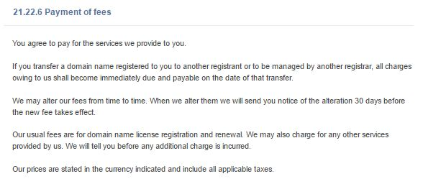

Figure Tax information on Terms and Conditions - Domain Names - .nz

# Hosting

This section gives plans for website hosting.

## Requirements

The website will contain a lot of multimedia contents (the client has 10,000 recordings).

Thus it is necessary to be able to use enough disk space and bandwidth.

We set following requirements.

|  |  |  |
| --- | --- | --- |
|  | Minimum requirements | Recommended requirements |
| Disk Space | 200GB | 400GB |
| Bandwidth | Unlimited | Unlimited |

**Disk Space**

Assuming that a multimedia file is 20MB on average, necessary disk space is 200GB (20MB * 10,000).

This is the minimum requirement.

Adding 100% buffer, recommended requirement is 400GB.

**Bandwidth**

We set unlimited because many moderate webhosting service plans provide unlimited bandwidth.

## Options

The following two are recommended regarding the requirements.

|  |  |  |
| --- | --- | --- |
|  | HostPapa Business | crazydomains Premium |
| Cost | 12 month @ $5.95/month = $71.40  24 month @ $4.95/month = $118.80  36 month @ $3.95/month = $142.20 | 12 months @ $7.50/month = $90.00  24 months @ $6.25/month = $150.00  36 months @ $5.77/month = $207.69  120 months @ $3.75/month = $450.00 |
| Disk Space | Unlimited | 500GB |
| Bandwidth | Unlimited | Unlimited |
| Domain Registration | Free (included) | Not included |
| Uptime | 99.9% Guarantee | 99.9% Guarantee |
| Security | Server Firewall  Monitoring & Intrusion Detection | DDoS Protection  Web Tracking |
| Backup | Automated Website Backup  (Optional @ $25.99/year) | File Backups |
| Support | 24/7 Multilingual Support (Chat / Email)  Telephone support | 24/7 Tech Support (Phone/ Email/ Live chat/ Online support portal/ Social network support) |
| Website | <https://www.hostpapa.co.nz/web-hosting-plan/> | <https://www.crazydomains.co.nz/web-hosting/> |

## HostPapa Business

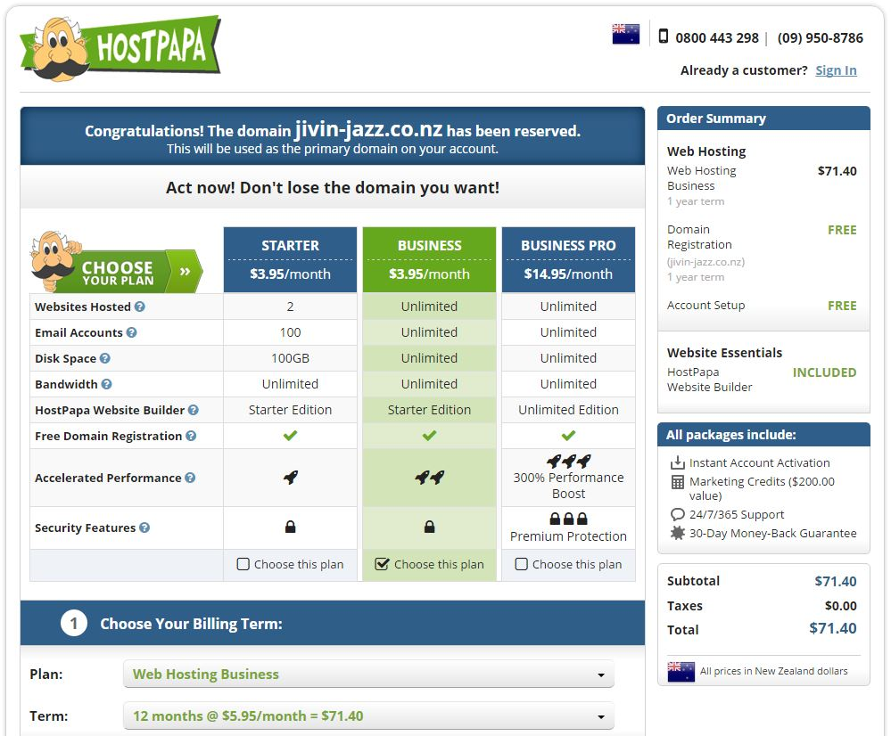

Figure HostPapa Business plan

## crazydomains Premium





Figure crazydomains Premium plan

# Copyright

The website and all of its contents (videos, photos, audios, texts, etc.) are copyrighted to Jivin’ Jazz. All rights reserved.

## Copyright notice

Following copyright notice will be put in the footer of all pages.

© Jivin’ Jazz, 2016.

## About copyright

Copyright is automatically protected by the Copyright Act 1994. The text of the Copyright Act can be found at [www.legislation.govt.nz](http://www.legislation.govt.nz). The contents of this website will be categorized into three different types of works in copyright protection.

* literary works (text contents, website codes)
* sound recordings
* films

Owners of copyright in **literary** **works** have the exclusive right to:

* copy their work (for example, by photocopying it, copying it by hand, reciting it onto an audio device or digital scanning);
* publish their work;
* in the case of computer programs, rent copies to the public in certain circumstances;
* communicate their work to the public (for example, on radio, TV or the Internet);
* perform their work in public; and
* make an adaptation of their work (for example by making a translation or a dramatized or pictorial version), or do any of the above activities in relation to an adaptation.

Owners of copyright in **films** and **sound recordings** have the exclusive right to:

* copy their material;
* issue copies to the public for the first time, by sale or otherwise;
* in the case of sound recordings and films, rent copies to the public;
* play or show their material in public; and
* communicate their material to the public.

# Privacy

The website will collect email addresses from the users. An email address is considered to be “Personal Information”, thus a Privacy Policy agreement is required for the website. The Privacy Policy agreement is the legal document or legal statement that discloses the important information to the users regarding their use of personal information:

* What information we collect.
* How we use that information.
* The choices we offer, including how to access and update information.

The Privacy Policy statement will be following.

This policy explains how we (Jivin’ Jazz) use any personal information we collect about you when you register to receive email newsletters. By registering for this service, you consent to the collection, retention and use of your personal information in accordance with the terms of this policy.

## Collection of information

We collect information about you when you register for the newsletter.

## How we will use your information

The information you provide will be used to send you email newsletters.

Recipient lists, including email addresses, are stored on a secure server for the purposes of email newsletter distribution.

This privacy policy only refers to the way Jivin’ Jazz will use your information.

## Unsubscribing

You can opt out from further communications at any point by selecting the unsubscribe link at the bottom of the newsletter. You can also contact us directly to request that you are removed from our mailing list.

# Usability testing

Usability testing is implemented to test if users can easily achieve tasks which we want the users to do in the website.

As a usability testing, we will set up tasks that include tasks in User interaction section. Participants who represent target audience will perform the tasks. The tasks will include following.

* Play a video of Pat Metheny.
* Play an audio of Pat Metheny.
* Find information about a recording.
* Subscribe to newsletter.
* Unsubscribe from newsletter.
* Write a comment to a blog post.
* Send email to Jivin’ Jazz.

# Timeline

|  |  |  |
| --- | --- | --- |
| Workload Breakdown Structure | Estimated Time (hrs) | What to do |
| Design | 30h |  |
| Common parts | 8h | Design page layout, fonts, colour scheme, etc. |
| Home page | 2h | Design contents layout, functions. |
| Recording List page | 2h | “ |
| Recording pages | 6h | “, Research recordings. 2h/page. |
| Musician Information page | 4h | “, Research the musician. |
| Blog page | 4h | “, Research articles. |
| About Us page | 2h | “ |
| Contact Us page | 2h | “ |
| Development | 20h |  |
| Home page | 4h | Code HTML & CSS. |
| Recording List page | 2h | “ |
| Recording pages | 6h | “, 2h/page |
| Musician Information page | 2h | “ |
| Blog page | 2h | “ |
| About Us page | 2h | “ |
| Contact Us page | 2h | “ |
| Testing | 46h |  |
| Functionality testing | 26h |  |
| Create test cases | 8h | Create test cases |
| Home page | 2h | Implement test cases. Fix bugs and defects. |
| Recording List page | 2h | “ |
| Recording pages | 6h | “ |
| Musician Information page | 2h | “ |
| Blog page | 2h | “ |
| About Us page | 2h | “ |
| Contact Us page | 2h | “ |
| Usability testing | 20h |  |
| Create test cases | 4h | Create test cases |
| Implement | 8h | Implement test cases |
| Fix | 8h | Fix bugs and defects |
| Delivery | - | 31 October 2016 |
| Total Time (hrs) | 96h |  |

# Budget

Development + 1 year running.

|  |  |  |
| --- | --- | --- |
| Item | Unit price | Cost |
| Developer | $26.00/h | $2,496.00 |
| Support and Maintenance (Monthly package) | $50.00/month | $600.00 |
| Website Hosting Service (Using HostPapa Business 1year) (incl. GST) | $83.40/year | $83.40 |
| Domain Name Registration | $0.00/year | $0.00 |
| GST (for Developer and Support and Maintenance) | 15% | $464.40 |
| Total | - | $3,643.80 |

## Support and maintenance

We have two options:

**Ad-hoc / Pay As You Go website support**

This works well for many of our customers giving you the option to pay an hourly rate of $26 for any required system updates, content changes, search engine optimisation or any other type of changes/fixes required on your website as and when you need.

**Monthly website maintenance package**

This option provides two hours per month for updates, fixes or any type of content changes, the cost starts from $50 per month. Additional time is then charged at a reduced rate of $23 per hour.

A monthly plan is more cost effective if you have frequent updates.